Experiment- 4
Branch: MCA (AI&ML) | Semester: 2
Student Name: Ajay Rakwal | UID: 25MCI10329
Subject Name: Technical Training | Subject Code: 25CAP-652
Section/Group: MAM-1(A) | Date of Performance: 03-02-2026

Aim of the program:
To understand and implement iterative control structures in PostgreSQL conceptually, including FOR loops, WHILE loops, and basic LOOP constructs, for repeated execution of database logic.

Software Requirements
- Operating System: Windows / Linux
- Database Management System: MySQL / Oracle / PostgreSQL
- SQL Interface: MySQL Workbench /Web Based / pgAdmin

Objective
- To understand why iteration is required in database programming
- To learn the purpose and behavior of FOR, WHILE, and LOOP constructs
- To understand how repeated data processing is handled in databases
- To relate loop concepts to real-world batch processing scenarios
- To strengthen conceptual knowledge of procedural SQL used in enterprise systems

Procedure of the Practical
- Open PostgreSQL using pgAdmin or a browser-based PostgreSQL interface and connect to the database.
- Study the need for iterative control structures in database programming through the given theory and real-world use cases.
- Write and execute a simple FOR loop to understand fixed-iteration execution.
- Implement a FOR loop with query-based iteration to process records one row at a time.
- Implement a WHILE loop to observe condition-controlled repeated execution.
- Use a LOOP construct with an EXIT WHEN condition to understand flexible and custom termination logic.
- Apply a FOR loop to simulate real-world batch processing such as salary increment for employee records.
- Combine LOOP and IF conditions to perform decision-making during iteration.
- Observe the execution flow and output messages to understand how iterative logic works in PostgreSQL.

Practical / Experiment Steps
-- employee table (used in examples)
CREATE TABLE employee (
emp_id INT,
salary INT
);
INSERT INTO employee VALUES
(1, 30000),
(2, 35000),
(3, 40000);

-- Example 1: FOR Loop
DO $$
BEGIN
FOR i IN 1..5 LOOP
RAISE NOTICE 'Iteration: %', i;
END LOOP;
END $$;

-- Example 2: FOR Loop with Query
DO $$
DECLARE
rec RECORD;
BEGIN
FOR rec IN SELECT emp_id FROM employee LOOP
RAISE NOTICE 'Processing Employee ID: %', rec.emp_id;
END LOOP;
END $$;

-- Example 3: WHILE Loop
DO $$
DECLARE
counter INT := 1;
BEGIN
WHILE counter <= 5 LOOP
RAISE NOTICE 'Counter value: %', counter;
counter := counter + 1;
END LOOP;
END $$;

-- Example 4: LOOP with EXIT WHEN
DO $$
DECLARE
num INT := 1;
BEGIN
LOOP
RAISE NOTICE 'Number: %', num;
num := num + 1;
EXIT WHEN num > 5;
END LOOP;
END $$;

-- Example 5: Salary Increment Using FOR Loop
DO $$
DECLARE
rec RECORD;
BEGIN
FOR rec IN SELECT emp_id FROM employee LOOP
UPDATE employee
SET salary = salary + 1000
WHERE emp_id = rec.emp_id;
END LOOP;
END $$;
SELECT * FROM employee

-- Example 6: Combining LOOP with IF Condition
DO $$
DECLARE
rec RECORD;
BEGIN
FOR rec IN SELECT emp_id, salary FROM employee LOOP
IF rec.salary >= 40000 THEN
RAISE NOTICE 'Employee % : High Salary', rec.emp_id;
ELSE
RAISE NOTICE 'Employee % : Normal Salary', rec.emp_id;
END IF;
END LOOP;
END $$;

I/O Analysis (Input / Output)
Input
- Table creation queries
- Sample data insertion commands
- Loop-based PL/pgSQL blocks (FOR, WHILE, and LOOP)
- IF–ELSE conditional logic inside loops
- UPDATE statements executed within loop constructs
- SELECT queries to display processed results

Output
- Tables created successfully
- Records inserted and processed correctly
- Iterative execution performed as per loop logic
- Conditional classification applied correctly using IF–ELSE
- Data updated accurately during iteration
- Correct execution flow and messages displayed for each loop operation

OUTPUT:
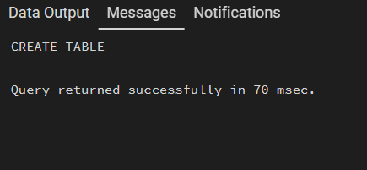
Table Created:

Insert sample records:
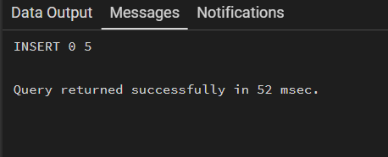

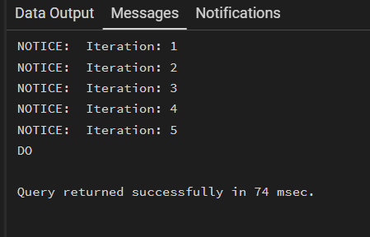
-- Example 1: FOR Loop

-- Example 2: FOR Loop with Query
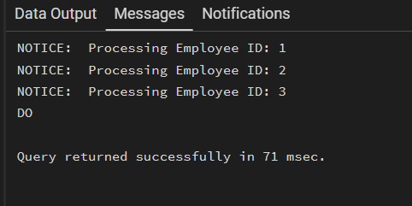

-- Example 3: WHILE Loop
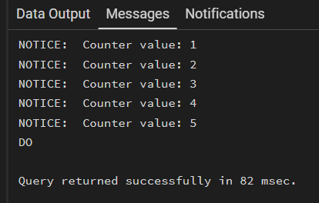

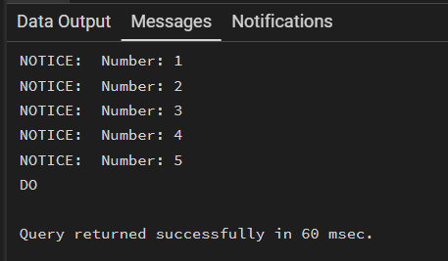
-- Example 4: LOOP with EXIT WHEN

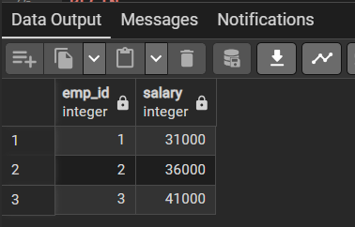
-- Example 5: Salary Increment Using FOR Loop

-- Example 6: Combining LOOP with IF Condition
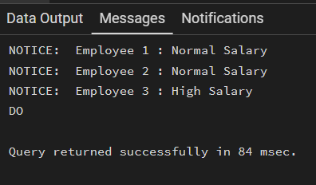

Learning Outcome:
- Understand the need for iteration in database programming and procedural SQL.
- Learn the working principles and use cases of FOR, WHILE, and LOOP constructs in PostgreSQL.
- Gain conceptual clarity on how repeated data processing is handled using PL/pgSQL.
- Relate loop-based database logic to real-world applications such as payroll, reporting, and batch jobs.
- Develop foundational knowledge required to write procedural and enterprise-level database programs.

